TECHNICAL PROJECT REPORT

# Title of Invention / Project:

**Isolated lock mechanism, Bluetooth app**

# Team Members / Inventors:

|  |  |  |  |  |  |
| --- | --- | --- | --- | --- | --- |
| **S.No.** | **Name** | **Department** | **Designation** | **Mobile** | **E-Mail** |
| 1. | Kushal kumar | ECE | STUDENT | 9381002108 | Kushal7399@gmail.com |
| 2. | Harshit | ECE | STUDENT | 8053939070 | harshitgarg44315@gmail.com |
| 3. | Shivam | ECE | STUDENT | 9858406576 | Shivamnagri5@gmail.com |
| 4. | Khushal Thakur | ECE | Mentor | 9646030764 | khushal.thakur@cumail.in |
| 5. | Anshul Sharma | ECE | Mentor | 9478697475 | anshulsharma.ece@cumail.in |
| 6. | Kiran Jot Singh | ECE | Mentor | 9463909689 | kiranjotsingh.ece@cumal.in |
| 7. | Divneet Singh Kapor | ECE | Mentor | 9878422653 | divneet.ece@cumail.in |
|  |  |  |  |  |  |

Section – 1 (IPR Related)

# Brief Abstract :

No need to carry keys. We can operate the lock from the distance that is no need to come near the door to open it.

We are using Bluetooth and operating it through mobile phone with the help of an app.

We can also operate through wifi.

# Existing state-of-the-art and Drawbacks in existing state-of-the-art

|  |  |  |
| --- | --- | --- |
| **S.NO** | Existing state of art | **Drawback in existing state of art** |
| 1 | bluetoooth | Short range |

# Novel/Additional modifications that you can propose to improve upon drawbacks

* We can unlock the lock by keeping password by using keypad and lcd.
* We can unlock the door using finger print.

# Advantages

(*List down the advantages, if each feature is incorporated)*

* We can operate the lock from anywhere.
* No need to carry keys, we can operate through keys.

Use generic block diagram:

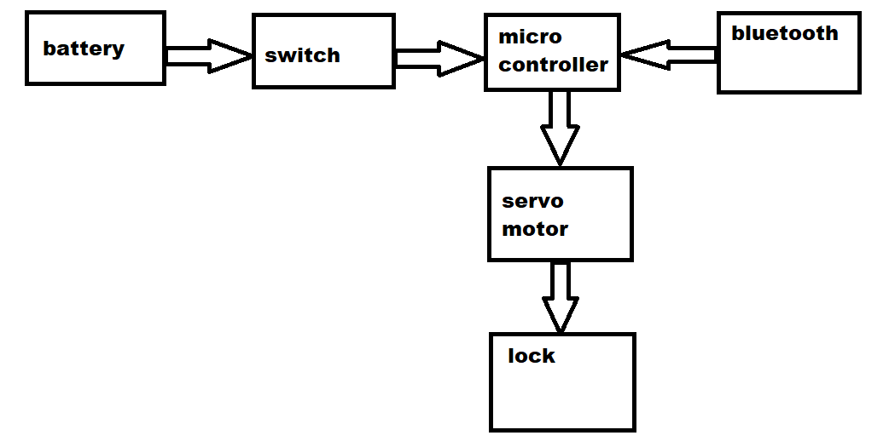Section – 2 (Real Project)

# Materials

Aurdino uno, lock, bluetooth module (hc-05), servo motor, jumper wires,

# Circuit Diagram:

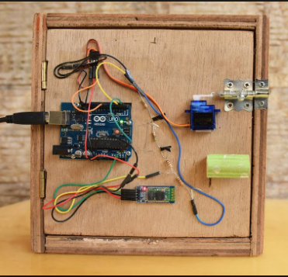

# Steps of Circuit Completion

Step1:

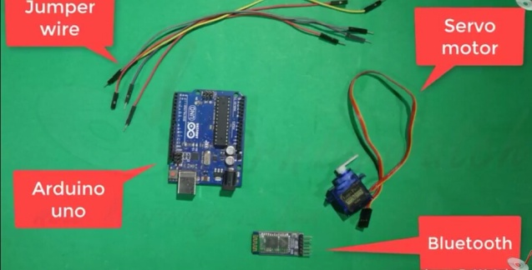

Step2:

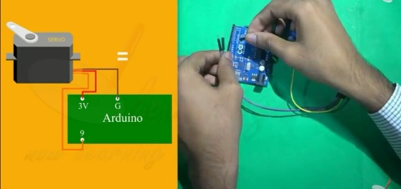

Step3:

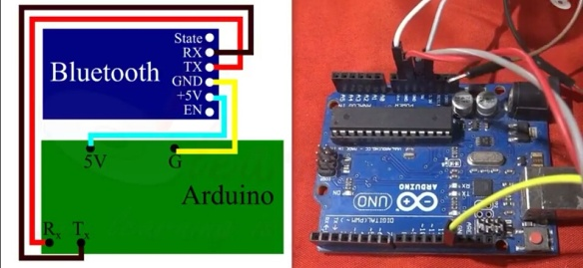

Step4:

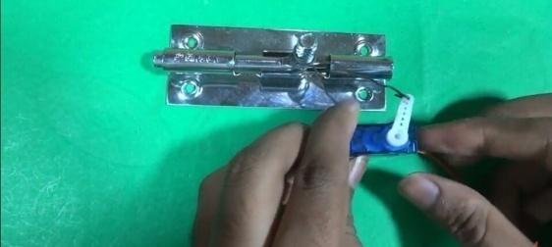

Step5

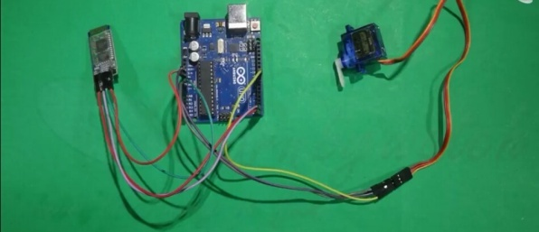

Step6:

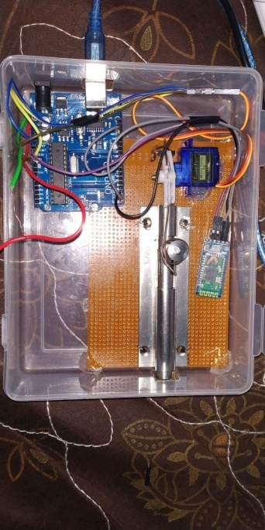

# Program Code

https://github.com/18bec1028/beee-lab-project/blob/master/isolation%20door%20lock-bluetooth%20app/include.docx